Weight to Waist Ratio for Men
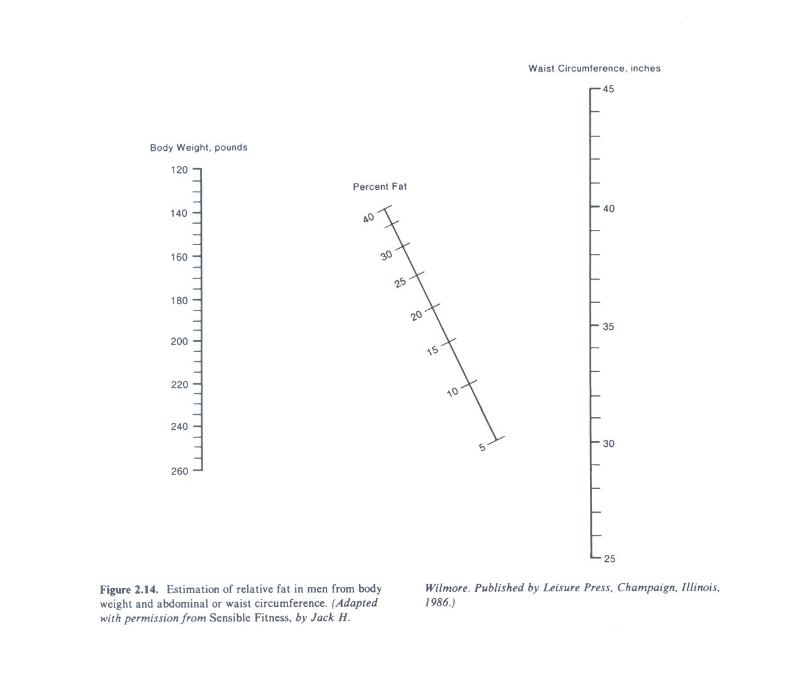
Height to Hip Ratio for Women
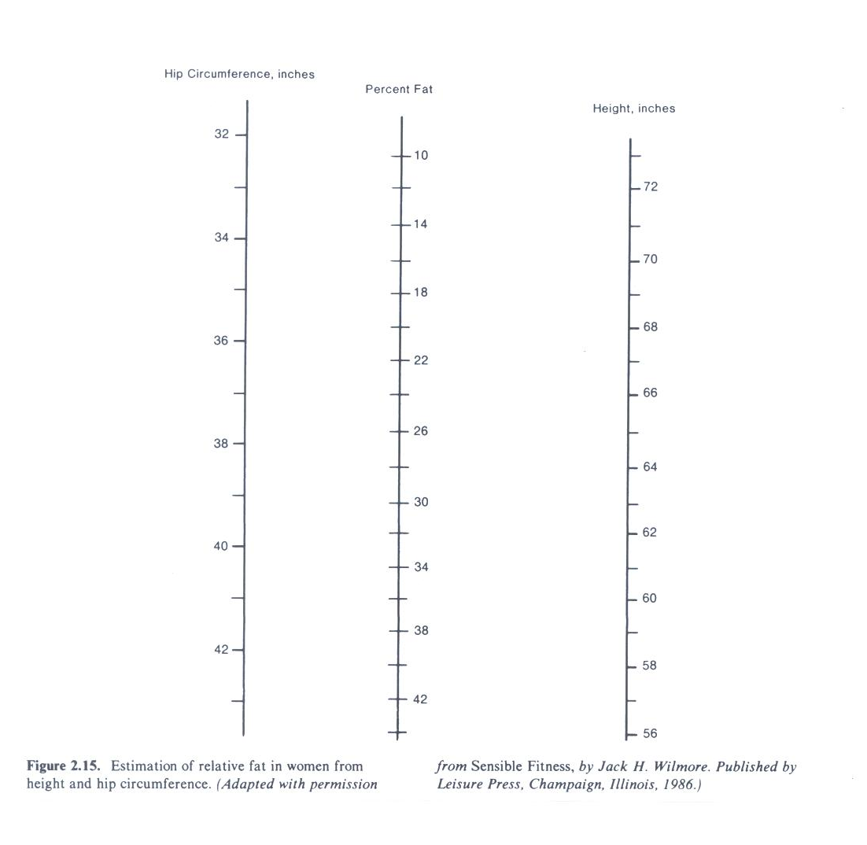
Skinfold Chart
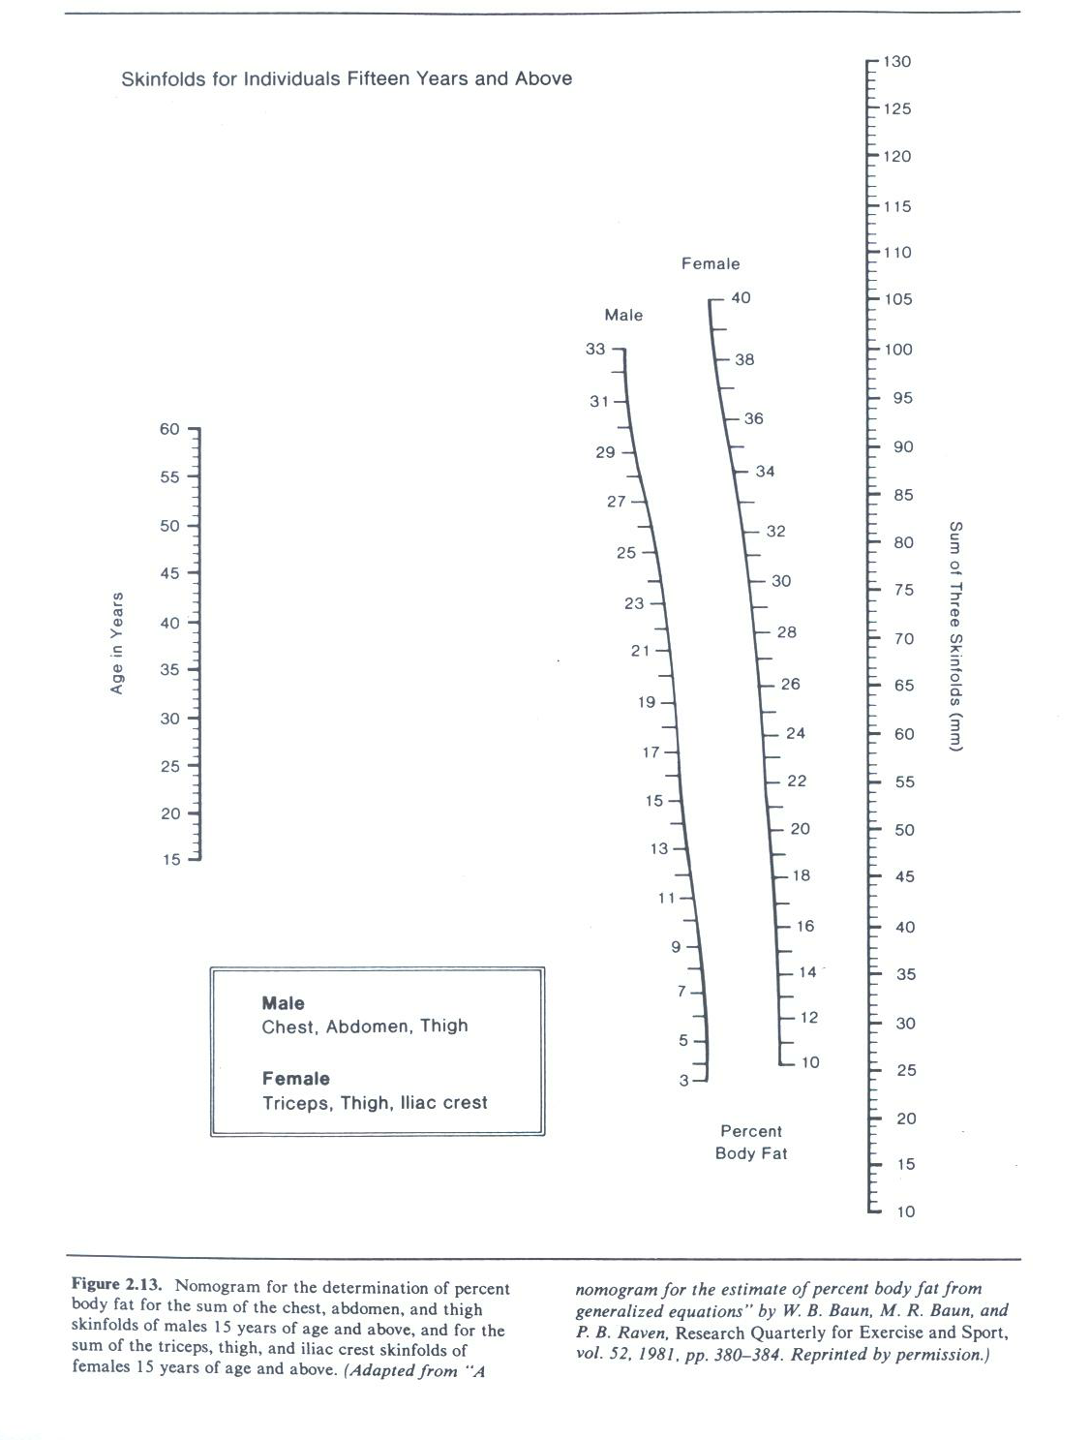
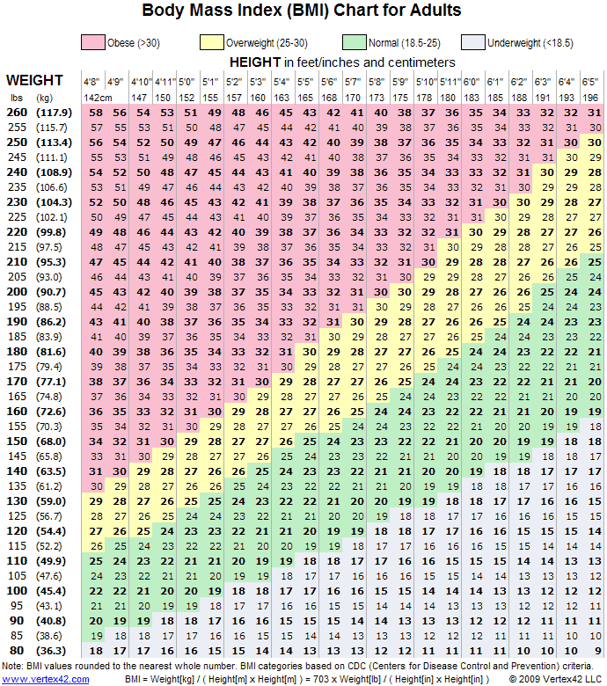
Body Composition

- Body Measurements
Males: Females:
Weight measurement __________ Height measurement ___________
Waist measurement ___________ Hips measurement ____________
Percent body fat _____________ Percent body fat _____________

- Skinfold Measurements:
Males: Females:
Chest measurement _____________ Triceps measurement ___________
Abdomen measurement ___________ Iliac crest measurement ____________
Thigh measurement ______________ Thigh measurement _______________
Sum of skinfolds ______________ Sum of skinfolds____________
Percent body fat ______________ Percent body fat ___________

- Body Mass Index
Height ____________
Weight ___________
Body Mass Index ____________
BMI Rating ____________

- Waist-Hip Ratio
Waist measurement ___________
Hip measurement ___________
WHR _______________
Rating ______________

